

**BHARATI VIDYAPEETH’S COLLEGE OF ENGINEERING**

A-4, PASCHIM VIHAR, ROHTAK ROAD, NEW DELHI-110063

AFFILIATED TO

GURU GOBIND SINGH INDRAPRASTHA UNIVERSITY, DELHI

**MAJOR PROJECT SYNOPSIS**

**Optical Table Generator**

|  |  |  |  |  |
| --- | --- | --- | --- | --- |
| **S. No.** | **Name of Student** | **Enrollment number** | **First Review** | **Second Review** |
| **1.** | **Ankit Dahiya** | **01111502713** |  |  |
| **2.** | **Sanjeev Sharma** | **01911502713** |  |  |
| **3.** | **Himanshu Bansal** | **02311502713** |  |  |
| **4.** | **Chandan Malla** | **03811502713** |  |  |

**Mentor Name: Mr. Vishal Sharma**

**Mentor Signature:**

# INDEX

1. Introduction........................................................................................3
2. Review of Literature...........................................................................3
3. Objectives of the Study......................................................................5
4. Research and Methodology................................................................5

1. Scope of the Project............................................................................6
2. Milestones and Timeline of Activities................................................6

1. References..........................................................................................7

**Optical Table Generator**

## INTRODUCTION

Optical Table Generator is a process by which the scanner "recognizes" tables as well as blocks of text. Optical Table Generator is achieved with the help of OCR (Optical Character Recognition) and OpenCV (Open Source computer vision library). Optical Table Generator works because Image processing technology is able to recognize certain kinds of characters, lines or other shapes and distinguish them from each other with appropriate algorithms and methods. It can do this in two different ways. Optical Table Generator either works because the software has been programmed to "recognize" the table concerned or else it uses "intelligent character recognition", which doesn't need a database to work. In that case the Optical Table Generator works by a broader ability to recognize patterns and shapes.

**What is OCR?**

Optical character recognition (also optical character reader, OCR) is the mechanical or electronic conversion of images of typed, handwritten or printed text into machine-encoded text, whether from a scanned document, a photo of a document, a scene-photo (for example the text on signs and billboards in a landscape photo) or from subtitle text superimposed on an image.

**What is OpenCV?**

OpenCV (Open Source Computer Vision Library) is an open source computer vision and machine learning software library. OpenCV was built to provide a common infrastructure for computer vision applications and to accelerate the use of machine perception in the commercial products. Being a BSD-licensed product, OpenCV makes it easy for businesses to utilize and modify the code.

We plan to study, analyze and solve this problem along with some of the related problems in this project.

### REVIEW OF LITERATURE

Previous studies provide a comprehensive description of image processing techniques used for such type of problems. These problems are common in day to day life. The two exciting techniques included are Image Processing for table recognition and machine learning for recognizing writing.

Image Processing techniques for our project depends on what type of input we get from the image. Techniques such as Line Recognition, Image Cleansing and character recognition is included with variety of algorithm for the given task.

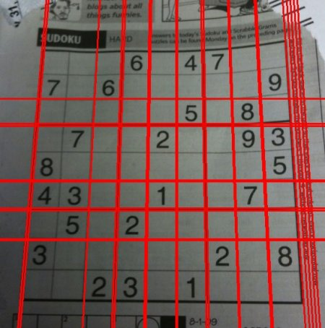

*(An output image of a Sudoku image after applying Hough Transform)*

**Hough Transform** is a popular technique to detect any shape, if you can represent that shape in mathematical form. It can detect the shape even if it is broken or distorted a little bit. We will see how it works for a line.

A line can be represented as y=mx+c or in parametric form, as ρ=xcosθ+ysinθ where ρ is the perpendicular distance from origin to the line, and θ is the angle formed by this perpendicular line and horizontal axis measured in counter-clockwise (That direction varies on how you represent the coordinate system. This representation is used in OpenCV).

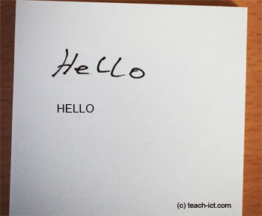

*(An output image after applying Optical character recognition)*

Machine learning Nearest neighbor classifiers such as the k-nearest neighbors algorithm are used to compare image features with stored glyph features and choose the nearest match. These models can be trained with training data to recognize character from the input image.

### OBJECTIVES OF THE STUDY

The aim of the project is to analyze and propose solutions to develop a software which will convert handwritten or printed text into editable and searchable tabular data., and to develop general purpose templates of the proposed solutions in commonly used programming languages. We plan to make solution codes public and free for educational purposes. We also tend to provide detailed description and tutorials for image processing used along with the test data created for testing purposes.

### Research and Methodology

Tools and Languages:

Python: is a widely used high-level programming language used for general-purpose programming, created by Guido van Rossum and first released in 1991. An interpreted language, Python has a design philosophy which emphasizes code readability (notably using whitespace indentation to delimit code blocks rather than curly braces or keywords), and a syntax which allows programmers to express concepts in fewer lines of code than possible in languages such as C++ or Java. The language provides constructs intended to enable writing clear programs on both a small and large scale

GCC/G++: The **GNU Compiler Collection** (**GCC**) is a compiler system produced by the GNU Project supporting various programming languages. Originally named the **GNU C Compiler**, when it only handled the C programming language, GCC 1.0 was released in 1987. It was extended to compile C++ in December of that year.

Git: **Git** is a version control system that is used for software development and other version control tasks. As a distributed revision control system it is aimed at speed, data integrity and support for distributed, non-linear workflows. Git was created by Linus Torvalds in 2005 for development of the Linux kernel, with other kernel developers contributing to its initial development.

Algorithms:

In this project we plan to modify various Image processing techniques and algorithms like Hough Transform, Image Thresholding, K-Nearest Neighbors and algorithms to solve the proposed problems.

**Scope of the Project:**

Future Scope for OTG is very vast. With technology like this anyone can scan a table from a magazine, a book or a document in seconds and can have digital copy of it with him forever and if you have a series of complicated tables as part of a larger image OTG will be extremely useful to be able to extract them with a scanner and edit them on screen. With further advancement it can be even more accurate than human eye.

**Milestones and Timeline of Activities:**

The entire project is divided into 4 phases

First Phase: It includes reading and understanding the common optical recognition problems, available research papers and studying various algorithms and data structures on Image processing to develop suitable approaches for the project.

Second Phase: It includes defining various problems, implementing various algorithms to solve these problems and iteratively making them efficient to reduce errors

Third Phase: This phase includes testing and improvisation. We will collect random images as test data to test our approaches for efficiency and accuracy. We also tend to analyze the solutions and identify their worst cases for algorithm changes. Final improvisations will be added to the codes.

Fourth Phase: It includes the documentation of the templates, test cases and description and explanation of the approaches used in the form of tutorials. We also tend to make most of the material freely available on the Internet in this phase.

## REFERENCES

1. Optical Character Recognition https://en.wikipedia.org/wiki/Optical_character_recognition
2. OpenCV https://en.wikipedia.org/wiki/OpenCV
3. Extracting data from PDF tables https://web.archive.org/web/20141022033241/http://craiget.com/extracting-table-data-from-pdfs-with-ocr/
4. “Can OCR software reliably read values from a table?” http://stackoverflow.com/questions/6173439/can-ocr-software-reliably-read-values-from-a-table